Export to HTML webpage design
Julia Schwarz

I’ve already written a basic export to HTML feature, but I really think it would be nice if the HTML of the export was similar to the UI of classroom presenter and Powerpoint. So, I’m proposing a new design for the webpage export:
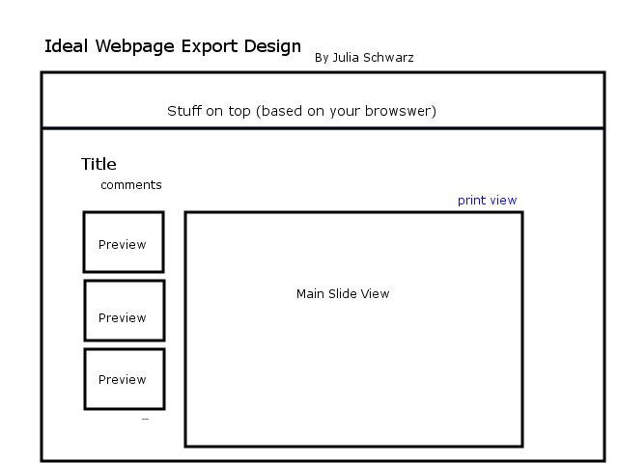

This would be my ideal design. Each of the larger slides would have a smaller preview version on the side, and when clicked would bring up the larger image in the main slide view. Also, users would be able to click the print view button to see the original version, which is much easier to print out.

Revision
I’m also thinking of using the following design, which will be simpler, and perhaps more useful:
